1.Closest Pair by Brute Force

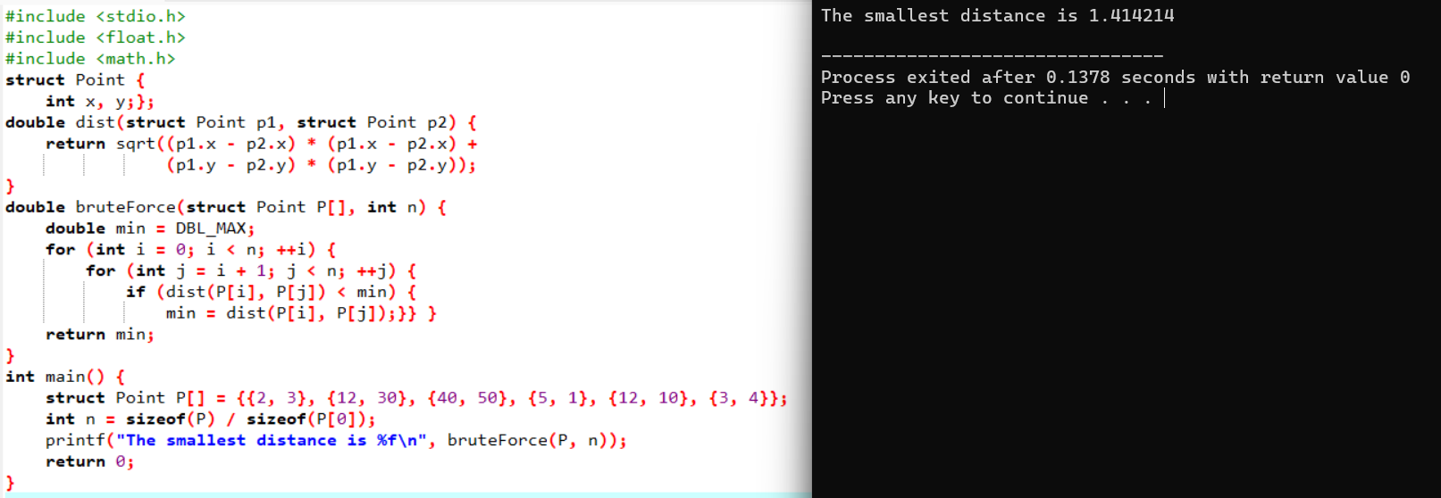

2.Convex Hull by Brute Force

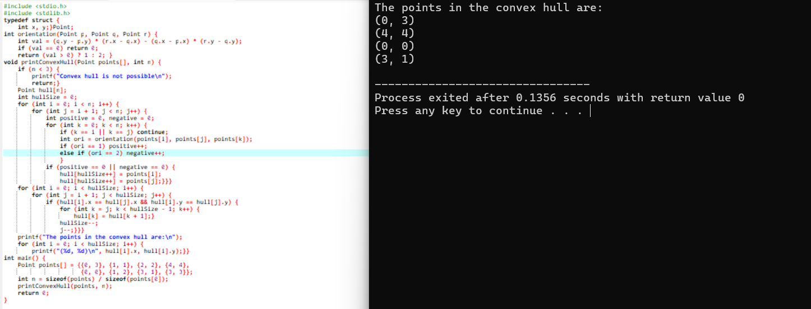

3.Exhaustive Search

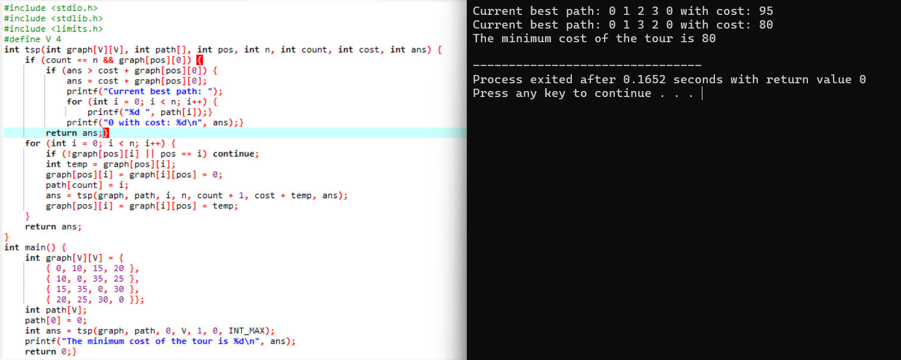

4.Assignment Problem (TSP) With Exhaustive Search

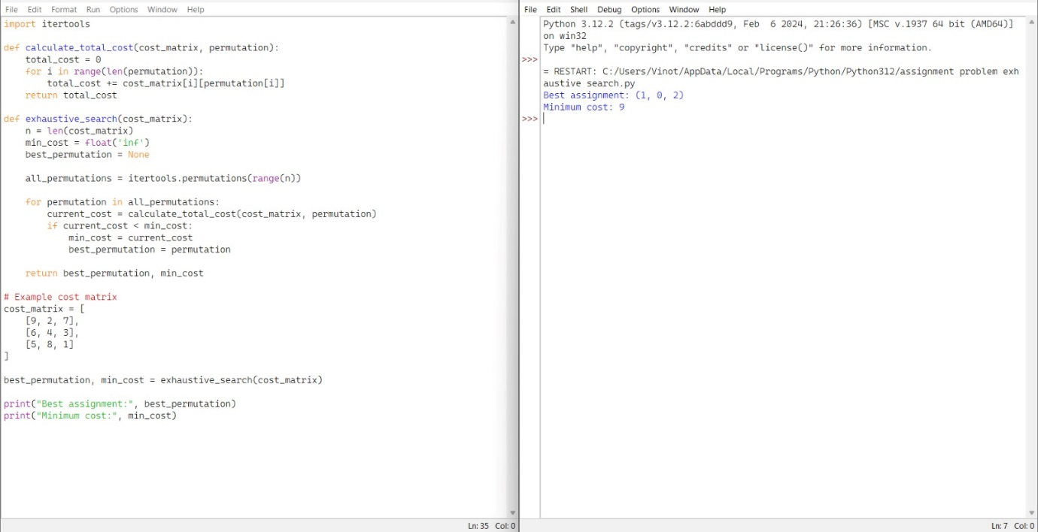

5.Knapsack Problem (TSP) With Exhaustive Problem

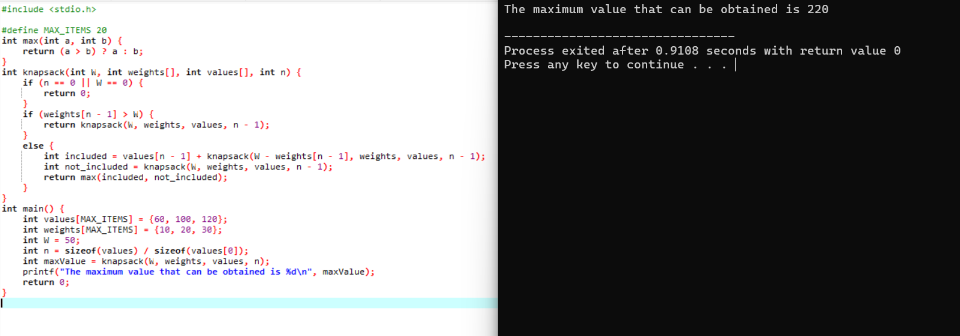

6.Dice Throw

